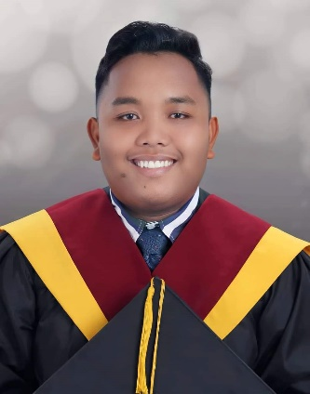 | JOHN MARK LANGUIDO  Lead Engineer, Costing and Standards  Ibabao, Cordova, Cebu, Philippines 6017 • 09158246780 • johnmarklanguido22@gmail.com
SUMMARY
Cost and process engineer with experience translating client specifications, materials, and labor requirements into accurate, data-driven cost estimates. Skilled at building and maintaining standardized costing structures, leading process engineering teams, and applying cost-control strategies that protect project profitability. Comfortable owning both the analytical side of costing and the people side of leading a team toward consistent, ISO-aligned standards.
EXPERIENCE
Lead Engineer, Costing and Standards | Passepartout Phils., Inc. July 2025 – Present
- Lead and supervise Standard Management Engineers, overseeing performance, feedback, and adherence to ISO standards and company work ethics.
- Analyze client documentation, drawings, and specifications to build accurate cost-to-make estimates using standard costing models for labor, material, and overhead.
- Compile project-specific costing through ERP costing modules and Excel, and flag risks or feasibility issues that could affect cost projections.
- Run post-production variance analysis, comparing estimated versus actual costs and recommending adjustments to costing models and structures.
- Supervise creation and approval of Standard Manufacturing Instructions (SMI), manage the SMI database, and oversee conversion of client-specific Development and Production Manufacturing Instructions (DMI/PMI).
- Coordinate with the Warehouse team on regular review of master and reference samples.
Cost Engineer / Process Engineer – Commercial Department | Passepartout Phils., Inc. 2022 – July 2025
- Developed cost and budget estimates for all clients, including detailed projections of labor hours and material consumption.
- Built and implemented cost control measures that improved project profitability and efficiency.
- Prepared cost reports and presented findings to senior management and stakeholders.
- Took on process engineering responsibilities over time: led process improvement initiatives, ran feasibility and cost-benefit studies, and maintained process documentation and SOPs.
- Provided technical guidance to project teams on cost-related matters and helped embed cost-management best practices across the department.
KEY ACHIEVEMENTS
- Implemented a cost control strategy that cut project expenses by 90%.
- Led a process optimization initiative that raised operational efficiency by 90%.
- Developed a cost estimation model that improved budget forecasting accuracy by 100%.
SKILLS
Core: Cost Estimation & Analysis, Budgeting & Forecasting, Process Optimization, Risk Assessment, Cost Control, Feasibility Studies, Process Documentation, Team Leadership
Software: Advanced Excel & Data Modeling, ERP Costing Modules, CAD, Microsoft PowerPoint & Word
Languages: English, Filipino
EDUCATION
Bachelor of Science in Mechanical Engineering — University of Cebu Lapu-Lapu and Mandaue, 2018–2022
STEM Strand, Senior High School — Cordova Catholic Cooperative School, 2016–2018

